Survey in Shivajinagar

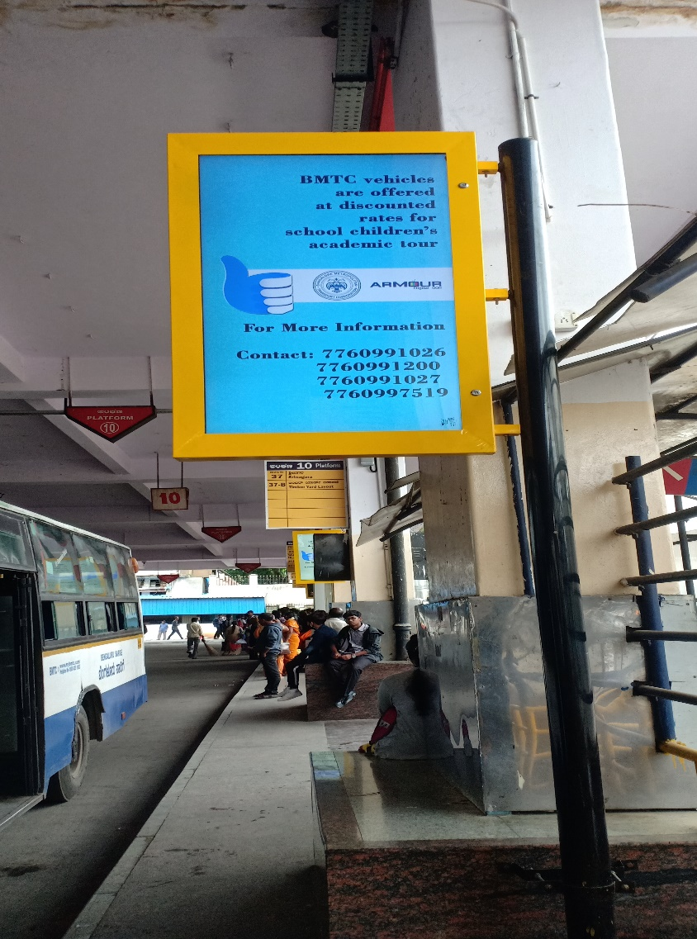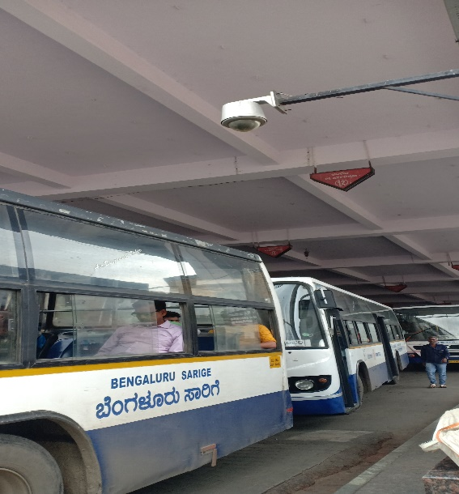 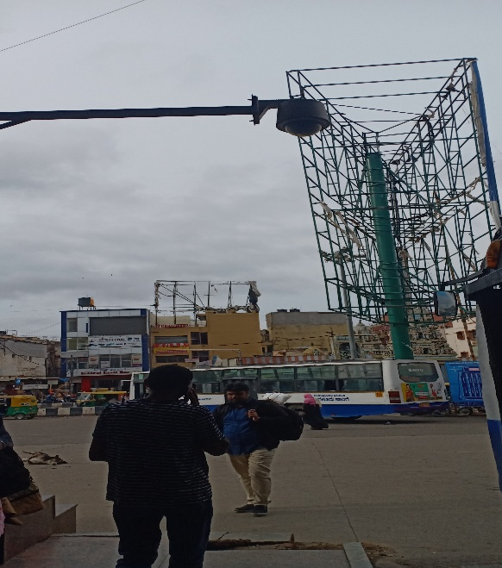 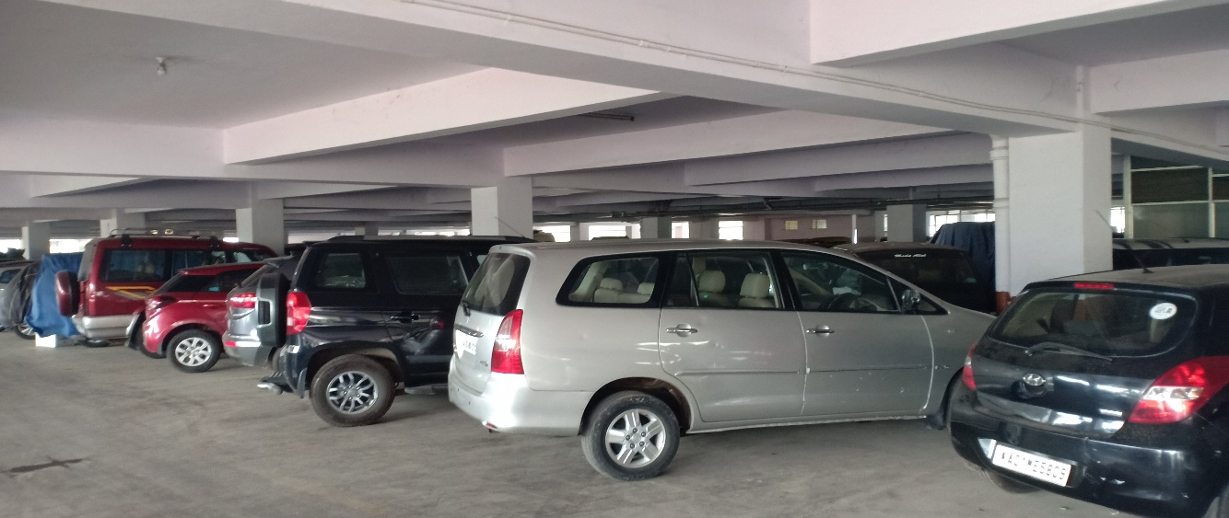 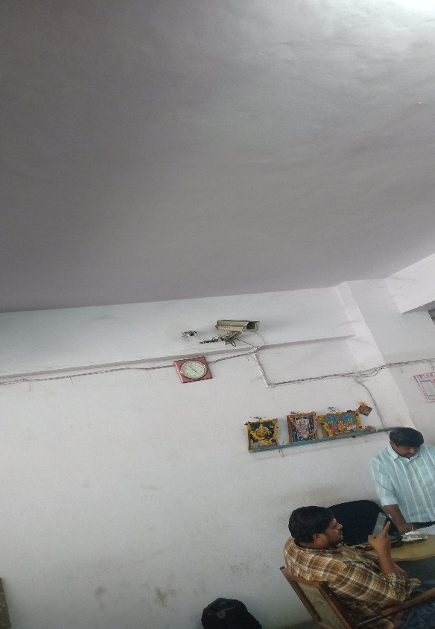 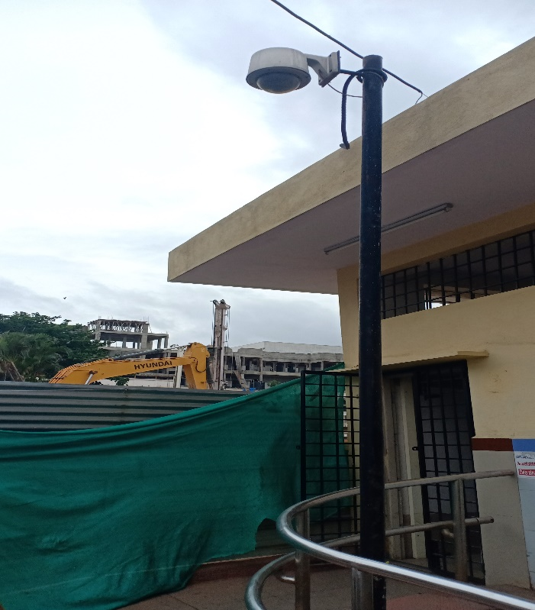

* It is recognized that the bus stand is under the control of CCTV Surveillance
* CCTV is located in the entry junction and exit junction.
* VMS System located in bus stand, where it displays important information to the citizens.
* They were no smart bins in the bus stand.
* The parking is allocated in the 1st and 2nd floor of the bus stand.
* Public toilet is constructed in the bus stand.